**Name: STEBIN BABU**

**Roll No:44**

**Batch:B**

**Date: 24-02-2022**

**NETWORKING & SYSTEM ADMINISTRATION LAB**

**Experiment No.: 1**

**Aim**

Familarization of linux commands.

**Procedure**

**1. pwd Command**

The pwd command is used to display the location of the current working directory.

**Syntax:**

**$pwd**

**Output:**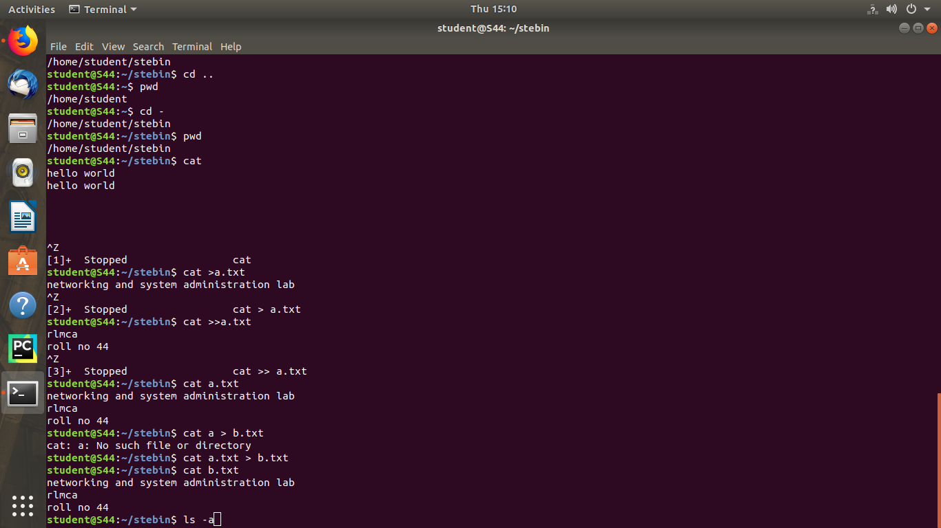

**2. mkdir Command**

The [mkdir](https://www.javatpoint.com/linux-mkdir) command is used to create a new directory under any directory.

**Syntax:**

$mkdir **<directory** name**>**

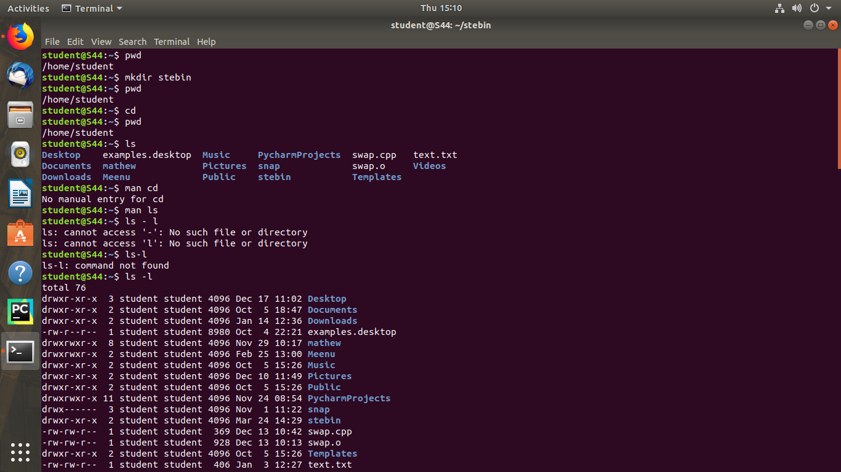**Output:**

**3. ls Command**

The [ls](https://www.javatpoint.com/linux-ls) command is used to display a list of content of a directory.

**Syntax:**

1. $ls

**Output:**



**3.1 ls - r Command**

The [ls](https://www.javatpoint.com/linux-ls)-r command is used to display list in reverse order.

**Syntax:**

$ ls -r

**Output:**

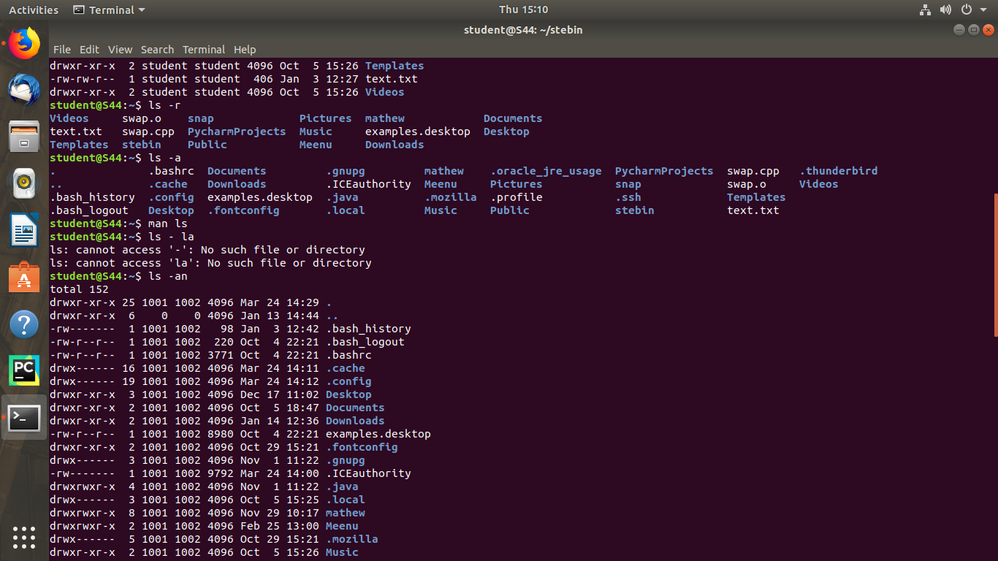

**3.2 ls - a Command**

The [ls](https://www.javatpoint.com/linux-ls)-a command is used to display list all files including hidden file starting with '.'

**Syntax:**

$ ls -a

**Output:**

**3.3 ls - l Command**

The [ls](https://www.javatpoint.com/linux-ls)-l command is used to display file or directory, size, modified date and time, file or folder name and owner of the file, and its permission.

**Syntax:**

$ ls -l

**Output:**

**4. cd Command**

 The [cd](https://www.javatpoint.com/linux-cd) command is used to change the current directory.

**Syntax:**

$ cd

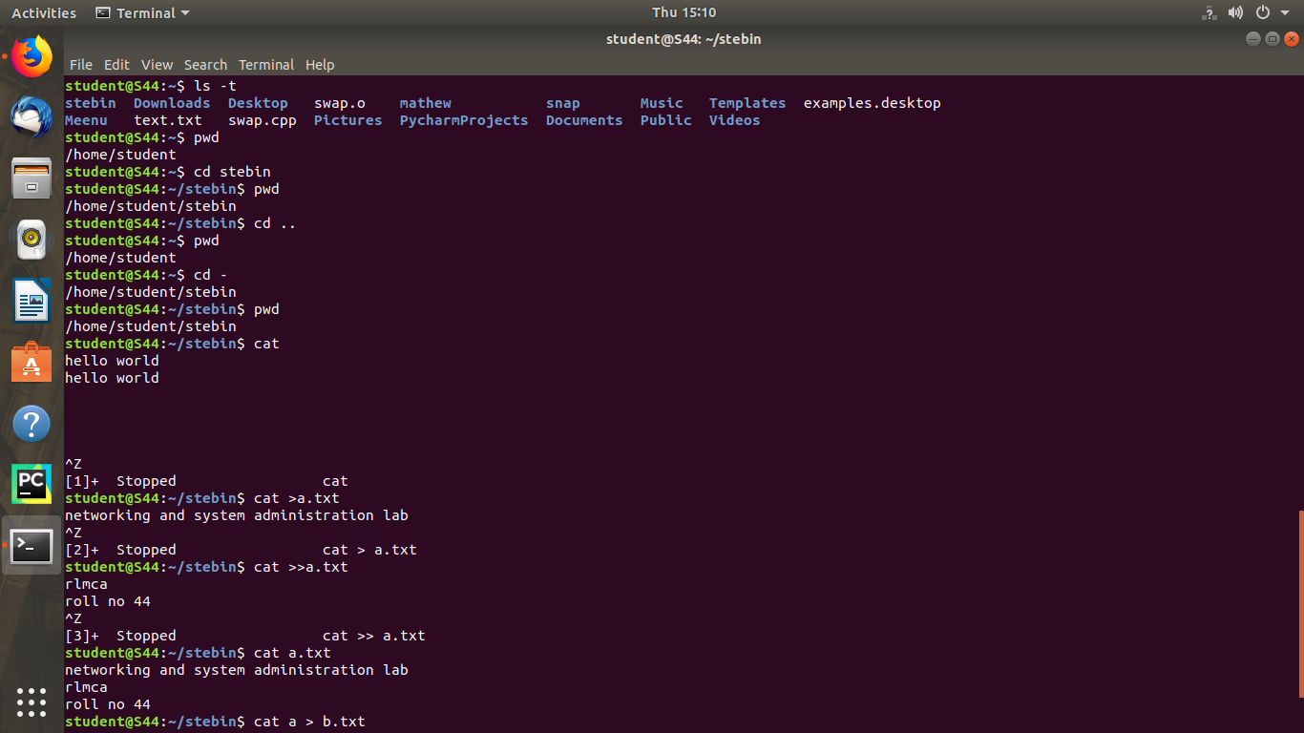**Output:**

**4. cd Command**

 The [cd](https://www.javatpoint.com/linux-cd) command is used to change the current directory.

**Syntax:**

$ cd [directory_name]

**Output:**

**4.1 cd .. Command**

 This command is used to move to the parent directory of current directory, or the directory one level up from the current directory. “..” represents parent directory.

**Syntax:**

$ cd ..

**Output:**



**4.2 cd - Command**

 This command is used to.  change back to the previous working directory,

**Syntax:**

$ cd -

**Output:**



**5.cat Command**

The [cat](https://www.javatpoint.com/linux-cat) command is a multi-purpose utility in the Linux system. It can be used to create a file, display content of the file, copy the content of one file to another file, and more.

**Syntax:**

$ cat > newfile

**Output:**



**5.1cat >> Command**

The [cat](https://www.javatpoint.com/linux-cat) >> command is used to add additional content to the file.

**Syntax:**

$ cat >> file name

**Output:**



**5.2 file display Command**

To display the contents of the file.

**Syntax:**

$ cat file name

**Output:**



**5.3 Cat > Command**

**Copy the content of one file to another file**

**Syntax:**

$cat [filename-whose-contents-is-to-be-copied] > [destination-filename]

**Output:**

